**Round 2**

Experiment: Projection of Point and Conventions.

**1.Story Outline:**

Concepts covered in the module of Engineering Drawing are basics for further complex drawing like in Machine drawing and Automobile design etc. In this part of the module, we will go to have a discussion on the topic “Projection of point and conventions”.It’s not possible to sketch 3D space on a 2D plane. But there is an alternative to represent in which the whole visual is divided into front view, top view, and sometimes profile plane view on a 2D sheet. This different view of point in the 2D plane explains the position of a given point in 3D space, which all makes understanding 3D space(orientation of point) on a 2D plane easy.

**2.Story:**

**2.1 Set the visual stage description:**

The experiment starts with a blank cartesian plane displaying both variable panels set at zero. Further two buttons are located at the bottom right corner. One button is for displaying the exact position of the point and the other one is for the next step. In the next step, the point will appear in the cartesian plane. After that the projection of the point appears in front and top view.

**2.2 Set User Objective & Goals:**

* Understand the given instruction/comment.
* Apply it to the drawing step.
* Compare the upcoming step with the previous step(changes which happened to draw)
* And overview all steps in simulation together for better understanding.

**2.3 See the Pathway Activities:**

* Simulator screen appears.
* Set the coordinates from the panel at the right.
* Point will appear on the Cartesian plane
* Projection of point appears (FV&TV)

**2.4 Set the Challenges and Questions/Complexity/Variation**

**Pre-test:**

1. . If the point lies in the fourth quadrant its front view will lie ______ XY line.
2. . Above
3. .Below
4. .On the
5. .None

Ans: B

1. .If a point P is placed in between the projection planes. The distance from a side view to the reference line towards the front view and the distance between the top view and reference line towards the top view will be the same.
2. . True
3. .False

Ans: A

1. . A point in the 2nd quadrant is 15cm away from both the horizontal and vertical plane and orthographic projection is drawn. The distance between the points formed by the front view and the top view is____
2. .0
3. .30
4. .15
5. .15+ from profile plane

Ans: A

4). Projection of a point in the third quadrant will be

(a) Front view in VP

(b) Front view in HP

(c) Front view in PP

(d) None

Ans: A

5). Projection of a point in the first quadrant will be

(a) Front view in VP

(b) Front view in HP

(c) Front view in PP

(d)None

Ans: B

**Post-test:**

1. .Two points are placed in 1st quadrant of projection planes such that the line joining the points is perpendicular to the profile plane the side view and top view will be ________
2. . Single point, Two-point
3. .Two-point, Single point
4. .Single point, Single point
5. .Two-point,Two-point

Ans: A

1. .A point is 5m away from the VP and 4m away from PP and 3m away from the HP in 1st quadrant then projections are drawn on paper the distance between the front view and top view is ______
2. .7m
3. .8m
4. .9m
5. .5m

Ans: B

1. .If the point lies on XY line then it lies _____
2. .First quadrant
3. .Second quadrant
4. .Third quadrant
5. .Lies on the origin

Ans: D

1. . If the point is 4m in front of VP and 3m above HP then in XY line divide the distance between the front view and top view in _____ ratio.
2. .4:3
3. .3:4
4. .7:4
5. .7:3

Ans: B

5). Front view and top view projection of point lies in above XY line in orthographic projection, then its X and Y coordinates are

A). Positive and Negative

B). Positive and Positive

C). Negative and Positive

D). Negative and Negative

Ans: C

**2.5 Allow Pitfalls:**

**No**

**2.6 Conclusion:**

The time required to perform the virtual experiment.

The approximate time required to understand the procedure to perform the experiment would take about 10 min. The time required to complete the simulator part will be variables 5min. Thus, the total time required to perform the experiment will be around 15min.

Interpret, Apply, Compare and Combine are the cognitive level involved. Users have to follow the comments and instructions given. Then try to apply the given in the drawing in the coming step. Comparing the following step with the last step, the changes made in them. After finally overviewing the all steps and changes made, for better understanding. Through quizzes, users are able to interpret it better.

**2.7 Equation/Formulas(Theory):**

In Orthographic projection, projectors drawn from the endpoints of the object meet the plane of projection at right angles for having an exact view of the object(point) on the plane. The position of a point in engineering drawing is defined with respect to its distance from the three principal planes (vertical plane, horizontal plane, and profile plane).

* Vertical Plane:- Plane on which front view of the object is projected.
* Horizontal Plane:- Plane on which the top view of the object is projected.
* Profile Plane:- This is the plane is perpendicular to both vertical and horizontal plane, is often required in the machine or another drawing when the plan and elevation do not sufficiently give the shape and dimensions.

Theory:-

Starting with 3-D space.

For a given point in a 3-D space, first, we should have measurements from the data given and have an orthographic projection, following the conventions properly.

Here basically, there are two measurements we must require for the projection of point:

1. The distance of a point from the vertical plane, the distance we observed from the top view.
2. The distance of a point from the horizontal plane, distance observed from the front view.

X Y

So, this is the orthographic 2-D plane on which the measurements are transferred. And now the next important part is a convention, which one has to follow while drawing.

Convention:-

* Top views are represented by only small letters eg. p*.*
* Their front views are conventionally represented by small letters with dashes eg. p΄
* Profile or side views are represented by small letters with double dashes eg. p΄΄
* Projectors are shown as thin lines.
* The line of intersection of HP and VP is denoted as X-Y.
* The line of intersection of PP and VP is denoted as X1-Y1
* Measurements of projectors should also be drawn by side.

If we go for 3D space, it is divided into four quadrants. For every quadrant, there is a different orthographic projection.

* First quadrant: Projection on VP will be represented above XY line and HP will be below.
* Second quadrant: Projection on VP and HP both will be represented above XY line.
* Third quadrant: Projection on VP will be represented below XY line and HP will go above.
* Fourth quadrant: Projection on VP and HP both will go below XY line.

**Flowchart**

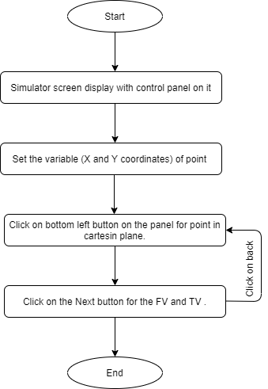

1. **Mindmap**

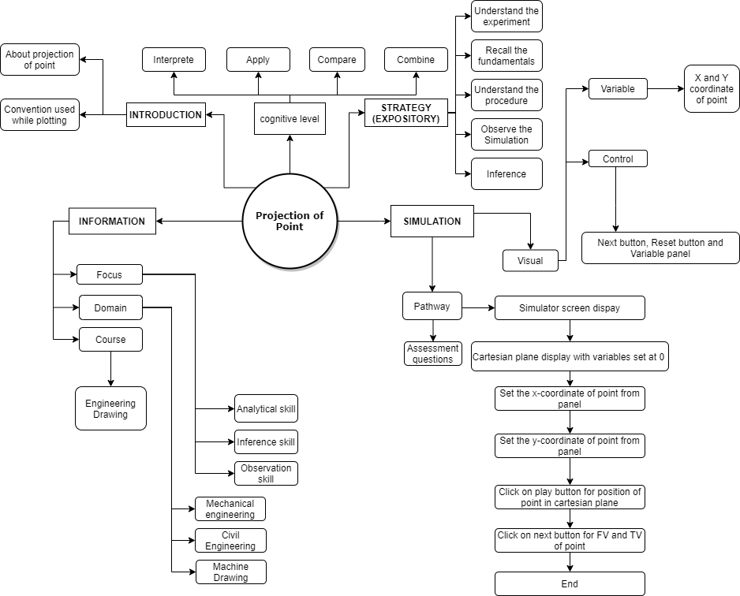

1. **Storyboard**
2. .**Open the simulation**, the screen will display a cartesian plane **with a control panel** on it.

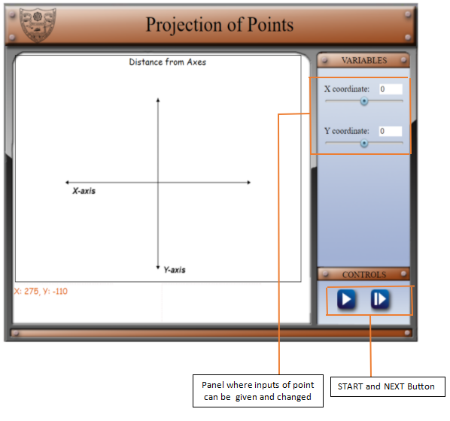

1. .Then **set the X and Y- coordinates of the point** from the panel. **Click on the button on the left** for the exact position of a point in the cartesian plane along with 3D orientation.

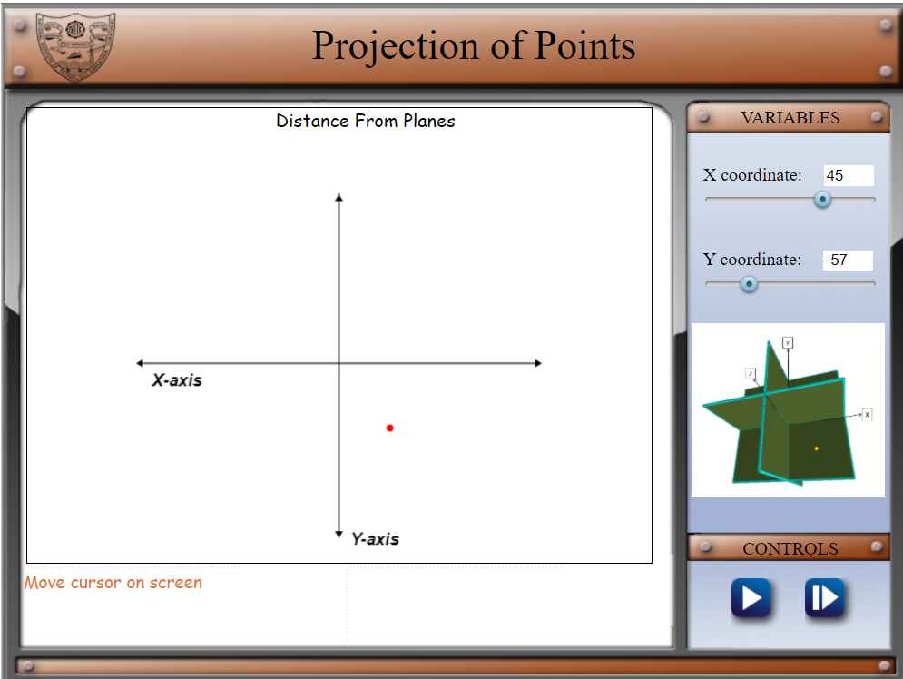

1. .**Click on the button on the right** for the next step(for the orthographic projection).

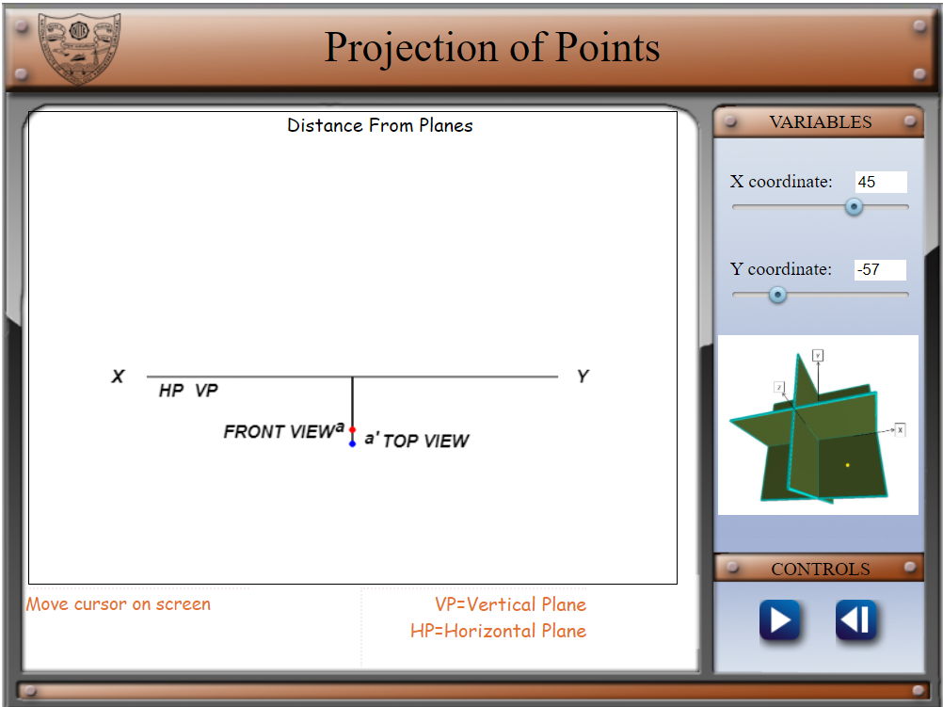

Here the simulation step ends and **for the previous step click on the button on the right**.